

CYBERSTER INTERNSHIP
BLUE TEAM
WEEK 7 REPORT
PRUDENCE NTHENYA
CSI-B1-479

Forensic Examination Report: Digital Media Artifact Analysis
​Case Reference: USB_Forensics_Lab_01
Lead Investigator: Prudence Nthenya
Date of Investigation: April 13-19, 2026
Evidence Identifier: 16GB Physical Removable Media
CSI-B1-479

Preliminary Data Acquisition
​Prior to analysis, a bit-stream image of the physical evidence was captured to ensure the preservation of digital integrity.
​Acquisition Tool: AccessData FTK Imager.
​Format: EnCase Evidence File (.E01). This format was selected for its industry-standard compression and its ability to store vital metadata, including MD5/SHA1 hashes, ensuring the evidence remains unchanged during the examination.
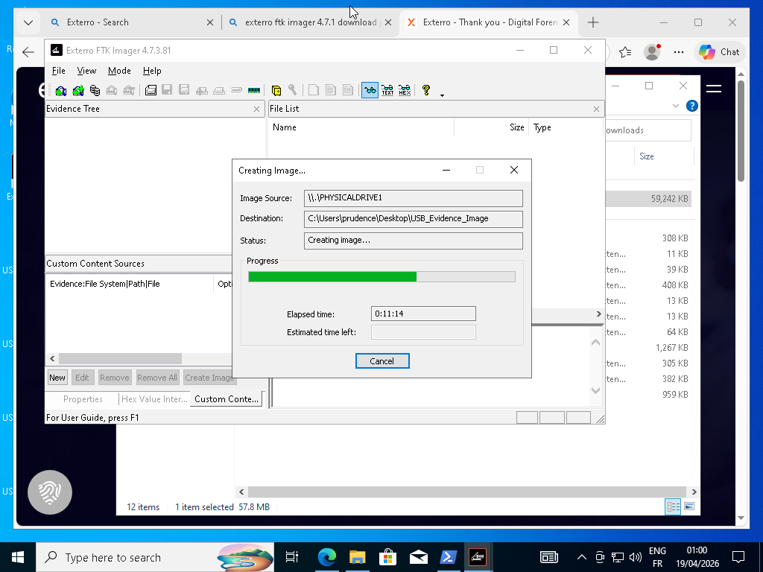
​Verification: A verification hash was generated at the time of capture. The resulting .E01 file served as the "Working Image" to prevent any direct interaction with the original physical hardware.

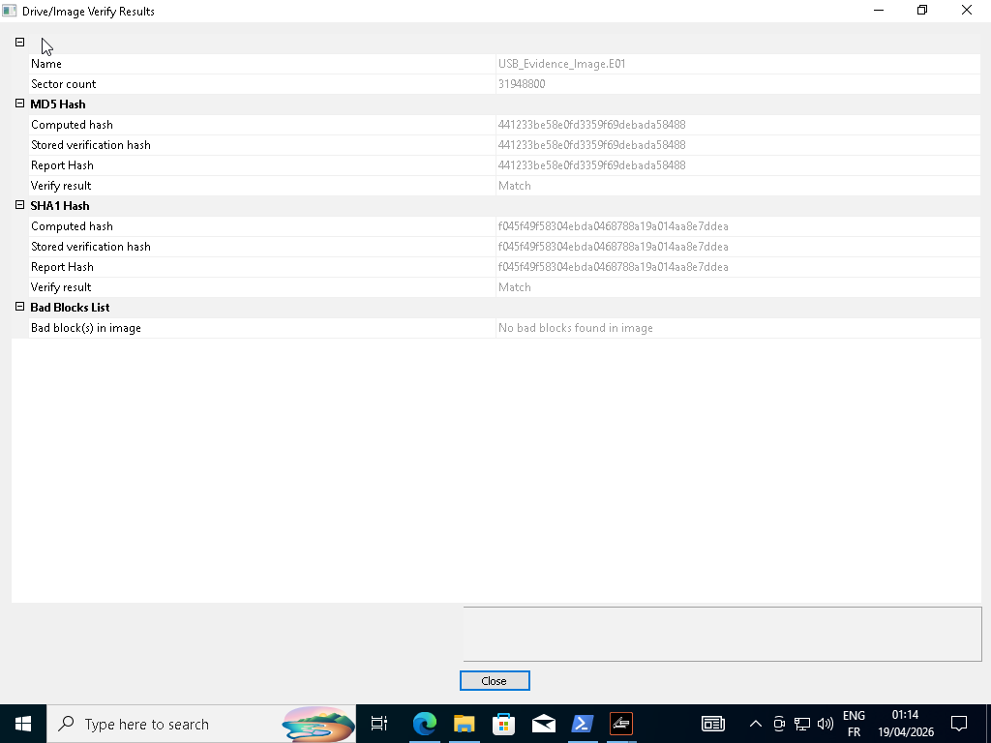
​

Investigative Environment & Tooling
​The forensic workflow was executed within a controlled, virtualized environment to isolate potential malware execution.
​Host OS: Ubuntu Linux.
​Guest OS: Windows 10 (executed via QEMU/KVM hypervisor).
​Primary Analysis Suite: Autopsy 4.23.0.

Forensic Methodology
​The "Working Image" was ingested into Autopsy with a focus on the following automated ingest modules:
​Recent Activity & File Type Identification: Used to categorize the 16GB of raw data.
​Keyword Search (Solr Indexing): Conducted targeted string searches for known malware families (njRAT, Wannacry).
​Data Carving (PhotoRec): Employed to attempt recovery of deleted files from unallocated clusters. Note: Sector-level read errors were documented in the unallocated space, suggesting partial data overwriting.
​Encryption Discovery: Scanned for specific cryptographic signatures and entropy levels.

Technical Findings & Evidence Analysis

​Operating System Artifacts

​The volume was definitively identified as an Ubuntu Installation ISO.
​SquashFS Containers: Detection of multiple compressed file systems (e.g., minimal.en.squashfs) confirms the media's intent as a bootable Linux environment.
​Bootloader Analysis: Autopsy flagged four (4) encryption-related modules (luks.mod, luks2.mod). Technical validation confirms these are legitimate GRUB components required for mounting encrypted Linux partitions and do not constitute malicious "ransomware" activity.
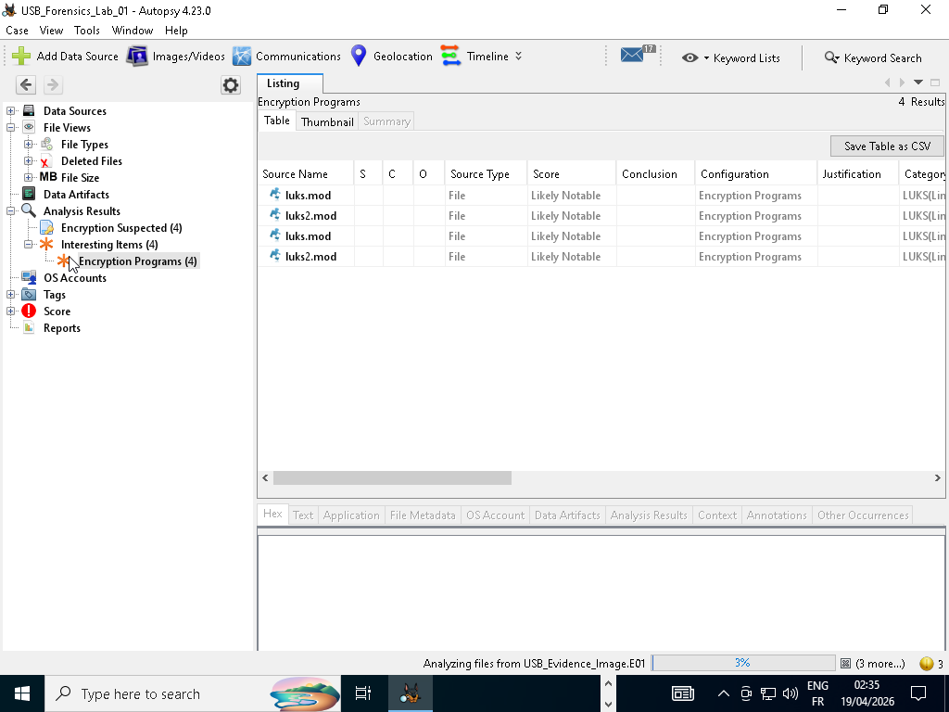
​

Malware Triage Results
​Executable Presence: The investigation returned zero (0) results for standard Windows executable extensions (.exe, .dll, .bat).
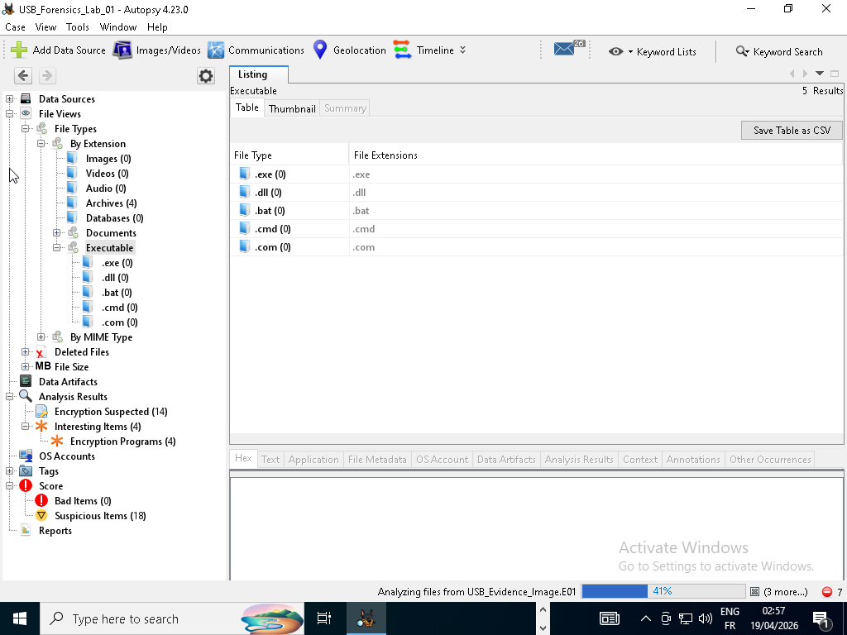
​Keyword Hits: Targeted searches for njRAT and Wannacry strings within the Solr index returned no matches.
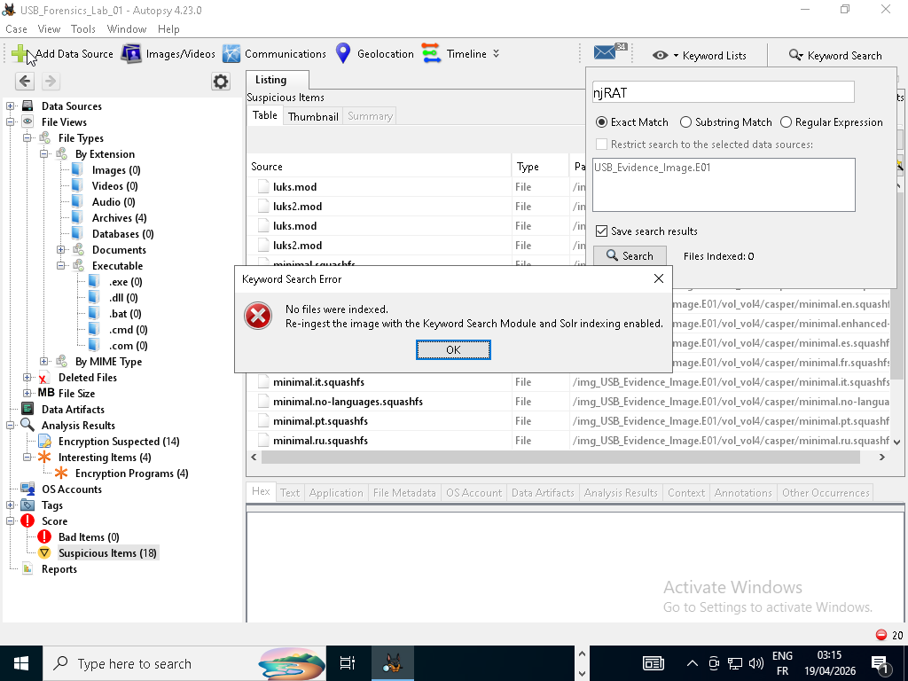
​Score Summary:
​Bad Items: 0 (No known malicious hash matches).
​Suspicious Items: 18 (Attributed to standard Linux OS system files and compressed containers).
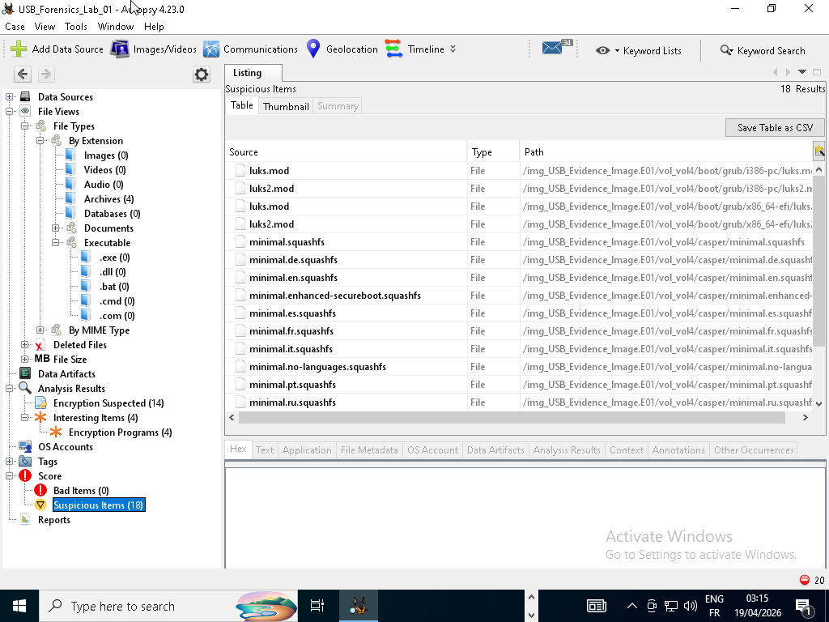

Final Conclusion
​The forensic evidence confirms the subject media is a standard, non-malicious Ubuntu Linux installation drive. The acquisition via FTK Imager and subsequent analysis in Autopsy yielded no indicators of compromise (IoCs) or presence of the targeted malware families.

​End of Report Report finalized and exported to HTML for chain-of-custody documentation.

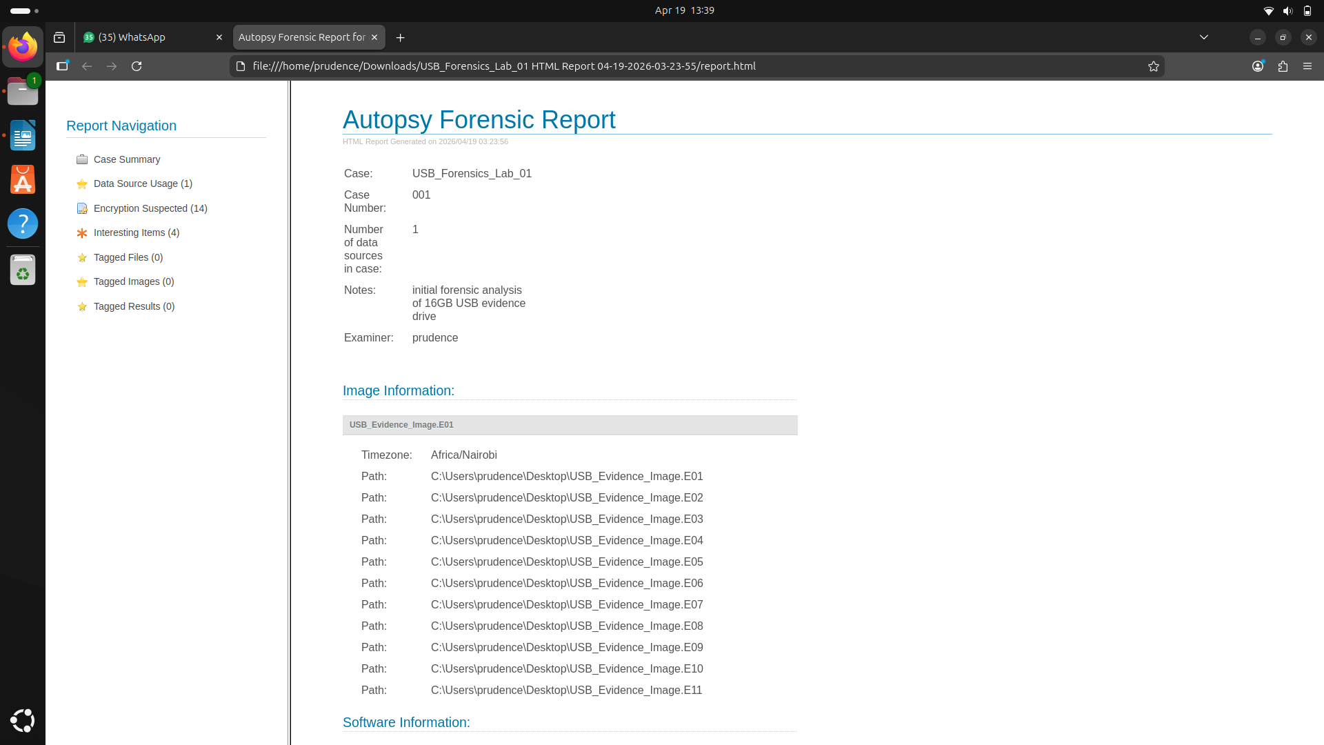
file:///home/prudence/Downloads/USB_Forensics_Lab_01%20HTML%20Report%2004-19-2026-03-23-55/report.html

